NUTRICYCLE
Quote Request — Pre-Launch Improvements
App Store (iOS) & Google Play (Android)
May 2026

Context
Nutricycle is a hormonal nutrition app in Spanish, organized by menstrual cycle phases (follicular, ovulatory, luteal, menstrual). It includes recipes with macros per serving, a hormonal note per ingredient, integrated recipe videos, a cycle tracker, and filters by phase and meal type.

After a competitive analysis of the apps Hormona and Bestie, we identified improvements to implement before publishing on the App Store and Google Play. This document includes technical specifications and visual references for each improvement.

Official brand color palette:
- Sage Green: #A3B3A5 (active filters, primary buttons)
- Mist Purple: #968DA1 (secondary filters, accents)
- Deep Text: #4A4453 (main text)
- Cream Background: #F9F9F2 (background of all screens)

High Priority Improvements
These improvements must be completed before launch.

Improvement 1 — Daily Meal Plan by Day of the Week
Reference app: Bestie
Create a new Nutrition screen showing a complete meal plan for the current day, organized by meal time.

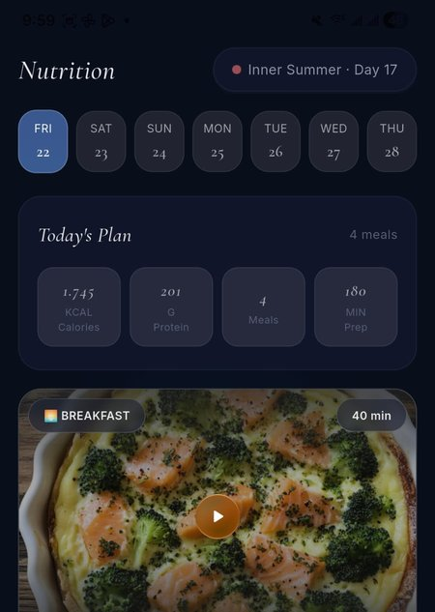
Reference: Bestie — Nutrition screen with daily plan, macros summary card and recipe cards by meal time
Specifications:
- Header with day-of-week selector (M-T-W-T-F-S-S), current day selected by default
- Daily summary card at top: total calories, total protein, number of meals, total prep time in minutes
- Recipe cards for each meal time: Breakfast, Lunch, Dinner, and Snack
- Each card shows: photo, recipe name, prep time, play button, and macros (cal / protein / carbs / fat) below the image
- Recipes must correspond to the user's current cycle phase
- Swap button per recipe: shows 3 alternative recipes from the same phase and meal type

Improvement 2 — Full Cycle Circular Tracker
Reference app: Bestie
Redesign the Cycle tab to display the complete menstrual cycle as a circle of colored dots, where each dot represents a day and each color represents a phase.

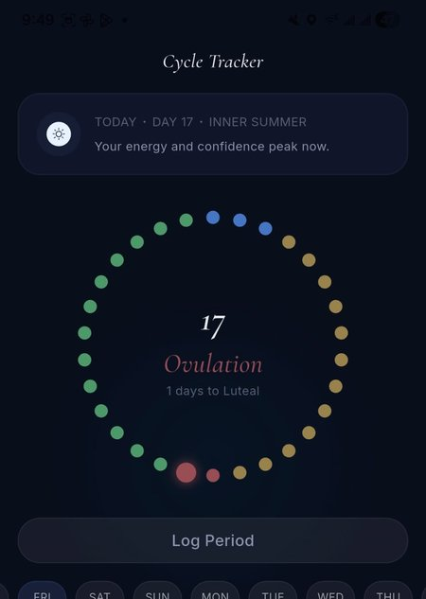
Reference: Bestie — Circular cycle tracker with colored dots per phase, day number in center, and Hormone Tides chart below
Specifications:
- Circle of dots matching the number of days in the user's cycle (typically 28-35)
- Colors per phase: Menstrual = soft red, Follicular = green, Ovulatory = blue, Luteal = gold/amber
- Current day dot: 1.5x larger with white border to stand out
- Inside circle: day number in large serif font, phase name below
- Below circle: days remaining until next phase
- 'Log Period' button visible and accessible from this screen
- Day-of-week selector below circle to navigate and view symptoms by day
- 'Hormone Tides' section: estrogen and progesterone curve chart with vertical line marking the user's current day

Improvement 3 — 'Key Foods' Section by Phase
Reference app: Hormona
Create a nutritional reference section accessible from the 'Today' screen or Cycle tab, showing recommended foods per phase organized by category.

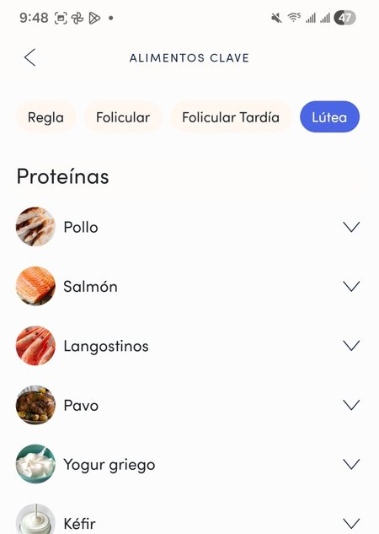
Reference: Hormona — Key foods list organized by phase (Luteal selected) and nutritional category with expandable items
Specifications:
- Phase filters at top: Menstrual / Follicular / Ovulatory / Luteal — user's current phase pre-selected
- Content organized by nutritional category: Proteins, Fats, Carbohydrates, Vegetables and Fruits
- Each food item: circular photo (48px), food name, expand chevron
- On tap: expands to show 2-3 lines explaining the hormonal benefit of that food for that phase
- Clean list design, cream background (#F9F9F2), consistent with app palette

Improvement 4 — Ingredient Cards with Hormonal Note inside Recipe
Reference app: Hormona
Inside each recipe screen, add an expandable section displaying key ingredients as individual cards with their hormonal explanation.

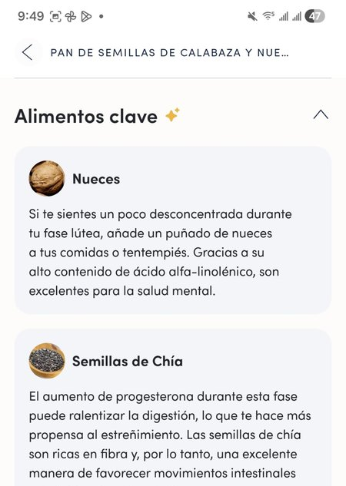
Reference: Hormona — Ingredient cards inside recipe showing food photo, name, and hormonal benefit text per phase
Specifications:
- Collapsible section called 'Key Ingredients' placed below the preparation steps
- Maximum 3 featured ingredients per recipe
- Each card: circular ingredient photo, name in bold, 2-3 line hormonal note specific to the recipe's phase
- Card background: cream (#F9F9F2) with subtle border
- Section starts collapsed and expands on tap

Improvement 5 — Smart Shopping List
No direct reference — original Nutricycle feature
Create a Shopping List feature that automatically generates a consolidated grocery list based on the user's selected meal plan for the week.

Specifications:
- User selects which days of the week they plan to cook from the daily meal plan (Improvement 1)
- App automatically generates a shopping list consolidating all ingredients from selected days
- Duplicate ingredients are merged and quantities added together
- Ingredients grouped by category: Proteins, Vegetables, Fruits, Dairy, Pantry, Grains
- Each item has a checkbox to check off while shopping
- Option to manually add extra items to the list
- Option to clear or regenerate the list for a new week
- Accessible from a dedicated tab or directly from the Nutrition screen

Medium Priority Improvements
These improvements can be implemented in the first week after launch.

Improvement 6 — Seamless Video Integration
Reference app: Bestie
Currently, videos appear as separate modules from the content below them with a visible cut. The video needs to flow seamlessly with the rest of the screen.

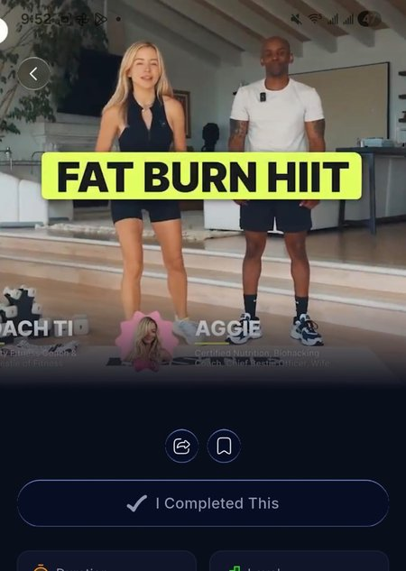
Reference: Bestie — Video occupies full screen width, content flows continuously below with no visual break between video and details
Specifications:
- Recipe thumbnail/photo spans full screen width with no lateral padding
- Recipe macros appear immediately below the image with no visual separation or independent container
- Remove any borders, margins, or shadows that create a separate module feeling
- Content should feel like a single continuous screen scrolling downward

Improvement 7 — Third Onboarding Question
No visual reference — addition to existing onboarding flow
Add a third screen to the onboarding questionnaire, after the 2 current questions about the cycle.

Specifications:
- Question: 'What is your main goal?'
- Options (select one): Hormonal acne / PCOS or Polycystic ovary syndrome / Irregular or painful periods / Inflammation and digestion / Fatigue and low energy / General hormonal balance
- Visual format: one card per option with representative icon, consistent with current onboarding screens
- Answer saved to user profile and used to personalize recipe order and home screen welcome message

Improvement 8 — Redesign of 'Today' Screen (rename from 'Home')
Reference app: Hormona
Rename the 'Home' tab to 'Today' and enrich the screen with hormonal context and quick access to key sections.

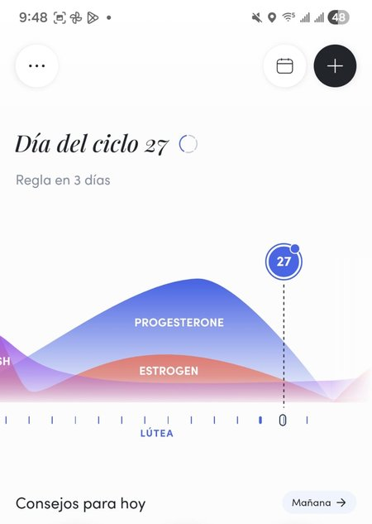
Reference: Hormona — 'Today' screen showing cycle day, hormone curve chart (estrogen & progesterone) with current day marked, and quick access circles to Nutrition, Wellness and Fitness
Specifications:
- Rename bottom tab from 'Home' / 'Inicio' to 'Today' / 'Hoy'
- Keep the hero image with current phase name and emotional description at the top
- Add hormone curve chart below the hero: estrogen and progesterone curves across the full cycle, with a vertical line marking the user's current day
- Add quick access circles below the chart: Recipes, Videos, Key Foods — each tappable and leading to the respective section
- Keep the 'Log how you feel' button
- Add suggested recipe of the day card at the bottom, corresponding to the user's current phase and time of day

Low Priority Improvements
These improvements can be included in a version 2.0 after launch.

Improvement 9 — Replace Placeholder Text on Videos Screen
On the Videos screen, category titles display 'VIDEOS.CATEGORY_PREFIX' instead of the actual category name. Replace with correct labels based on content type (e.g., 'Recipe', 'Hormonal Education', 'Tips').

Improvement 10 — Profile Screen Visual Redesign
The Profile screen header has a gray background inconsistent with the cream/sage palette of the rest of the app.

Specifications:
- Change profile header background to cream (#F9F9F2) to unify with the rest of the app
- Clarify the 'BALANCE' badge with gold crown: define whether it is the premium plan name or a status indicator, and make its purpose visually clear

Quote Summary Table
Please fill in your estimated cost (in USD) for each improvement in the 'Cost' column.

# | Improvement | Priority | Cost (USD)
1 | Daily meal plan by day of the week + recipe swap | High
2 | Full cycle circular tracker + hormone tides chart | High
3 | Key foods section by phase | High
4 | Ingredient cards with hormonal note inside recipe | High
5 | Smart shopping list (auto-generated from meal plan) | High
6 | Seamless video integration | Medium
7 | Third onboarding question + personalization logic | Medium
8 | Redesign 'Today' screen: rename + hormone chart + quick access circles + suggested recipe | Medium
9 | Replace placeholder text on Videos screen | Low
10 | Profile screen visual redesign | Low
 | TOTAL

App Store & Google Play Integration
Additionally, please quote the following for publishing the app on both stores:

Service | Cost (USD)
App Store (iOS) setup and publishing
Google Play (Android) setup and publishing
Testing on iOS and Android devices before launch
Store asset design (screenshots, app icon, preview video)
TOTAL — APP STORE & GOOGLE PLAY

Note: The Apple Developer Account ($99 USD/year) and Google Play Developer Account ($25 USD, one-time) are payments made directly to Apple and Google — not included in your quote.

Design Notes for the Developer

Principles to maintain across all new screens:
- Background always in cream (#F9F9F2) — never pure white or dark
- Serif typography for large titles, sans-serif for body text and UI elements
- Active phase filters use Sage Green (#A3B3A5)
- Active secondary filters use Mist Purple (#968DA1)
- Soft borders, rounded corners, no aggressive shadows — warm and premium aesthetic
- Every new screen must pre-filter content by the user's current cycle phase
- The user can always explore other phases freely — phase filter always visible

Nutricycle — Quote request for developer
May 2026 · Alicia Basurto · @aliciabasurto.coach

